

# Findings report Top 500 tax performance program – June 2024

Our Top 500 findings report shares insights about tax affairs of Australia's largest privately owned and wealthy groups.

This publication was current at 4 December 2024

**Contents**

About this report 3

Key findings 4

The Top 500 program 5

Top 500 program 5

Our future approach 5

Top 500 demographics 7

Top 500 population: who are they? 7

How much tax we assured 9

Commercial deals engagements 9

Audit results and importance of tax governance 11

Audit, review, and voluntary disclosure results 11

Importance of effective tax governance 13

Justified trust framework 15

Achieving justified trust and benefits for Top 500 groups 15

Differentiated approaches to assurance and justified trust 16

Tax governance and key issues for Top 500 groups 18

Tax governance 18

Tax issues for Top 500 groups 22

Top 500 client survey 25

Keep up to date 26

## About this report

What our findings report for the Top 500 tax performance program covers.

The Top 500 tax performance program (Top 500 program) gives the community confidence that Australia’s wealthiest privately owned groups are paying the right amount of tax.

This report provides our observations and insights from the program based on the 2023–24 financial year. If you control or represent a Top 500 group, you can use these findings:

* as guidance when reviewing your tax affairs and tax governance
* to increase your awareness of common tax issues
* to understand our current and future approach to Top 500 engagements.

## Key findings

Key findings, observations and recommendations from the 2023–24 financial year.

In 2023–24, our key findings were as follows.

* $1.646 billion in income tax paid by Top 500 entities was tax assured. This means we have a high level of confidence that the transactions and arrangements to which this amount relates have been correctly reported.
* Income tax liabilities of $552.5 million were raised, with $41.3 million from voluntary disclosures. Many liabilities arose from basic errors, and from groups with little or no documented tax governance, highlighting the importance of tax governance in avoiding costly errors.
* Our audits and reviews in progress reflect the complex arrangements, tax risks and potential non-compliance among some Top 500 groups. This reinforces the importance of maintaining adequate records to substantiate positions taken, and transparency in their dealings with us, to resolve compliance matters quickly.

## The Top 500 program

How we engage and support the Top 500 group to get their tax obligations right, and our future approach.

In this section

1. Top 500 program
2. Our future approach

### Top 500 program

The [Top 500 program](https://www.ato.gov.au/businesses-and-organisations/corporate-tax-measures-and-assurance/privately-owned-and-wealthy-groups/what-you-should-know/tax-performance-programs-for-private-groups/top-500-private-groups-tax-performance-program) is one of several programs administered as part of the [Tax Avoidance Taskforce](https://www.ato.gov.au/about-ato/tax-avoidance/tax-avoidance-taskforce). The objective of the Top 500 program is to provide the Australian Government and the community with confidence that Australia’s largest private groups are paying the correct amount of tax and will continue to pay the correct amount of tax in the future.

The Top 500 population changes over time as groups enter and leave based on the eligibility criteria. This is usually due to restructuring or following succession of a key controller. As of 30 June 2024, 435 private groups formed part of the Top 500 population.

The Top 500 program engagement model invites Top 500 groups to proactively demonstrate they are meeting, and want to continue to meet, their tax and superannuation obligations. They're engaged through ongoing, one-to-one engagements that take a holistic approach to assurance across the 4 key areas of justified trust.

If members of the Top 500 population don't wish to collaborate with us to demonstrate they are paying the correct amount of tax, we undertake assurance activities through firmer review and audit processes.

Some Top 500 clients are also included in the [Top 500 GST assurance program](https://www.ato.gov.au/businesses-and-organisations/corporate-tax-measures-and-assurance/privately-owned-and-wealthy-groups/what-you-should-know/tax-performance-programs-for-private-groups/top-500-private-groups-tax-performance-program/top-500-gst-assurance-program), providing a level of assurance as to whether these groups are correctly reporting the right amount of GST. These are integrated with the income tax assurance engagements to ensure a seamless experience for the Top 500 group.

In the longer term, our ongoing engagements with large private groups who seek to comply with their obligations are designed to:

* prevent disputes through early engagement on major transactions
* build mutual trust
* foster willing participation in the tax and superannuation systems.

### Our future approach

We are currently reviewing the Top 500 program and considering some changes to better align our approach with the objectives of the program. We'll focus on ensuring the expectations that the wealthiest private groups are kept to the highest tax compliance standards are met, while reducing the cost of compliance for the groups that get things right.

The review is looking at:

* updating the Top 500 program criteria to ensure we focus on the wealthiest private groups that have the greatest impact on the tax system
* how we can support and encourage groups to achieve justified trust, and clarifying the scope of the refresh-year review that occurs after 3 years of monitoring and maintenance
* reassessing the form of future engagements for certain groups that are fully tax assured.

Our differentiated approaches to assurance and justified trust will be maintained alongside any future changes.

Details of the review and future program updates will be available through our [Top 500 private groups tax performance program](https://www.ato.gov.au/businesses-and-organisations/corporate-tax-measures-and-assurance/privately-owned-and-wealthy-groups/what-you-should-know/tax-performance-programs-for-private-groups/top-500-private-groups-tax-performance-program) in the coming months.

## Top 500 demographics

Characteristics of the Top 500 groups and the amount of tax we have assured.

In this section

1. Top 500 population: who are they?
2. How much tax we assured
3. Commercial deals engagements

### Top 500 population: who are they?

The Top 500 population consists of Australia's largest and wealthiest private groups.

Based on 2022 tax returns, the Top 500 population controls over $373 billion in net assets, employs more than 670,000 people and contributes over $13 billion in income tax and GST each year. Given the economic size of these groups, even small errors can have a big tax impact. Their high profile means that their level of participation can influence community confidence, and perceptions of fairness, in the tax system.

Figure 1: Typical Top 500 group

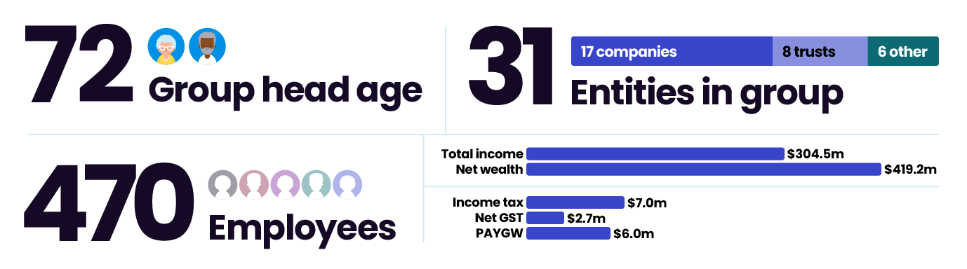

The typical top 500 group has:

* a group head age of 72
* 31 entities, consisting of 17 companies, 8 trusts and 6 other types of entities
* 470 employees
* total income of $304.5 million
* net wealth of $419.2 million
* income tax of $7.0 million
* net GST of $2.7 million
* PAYG withholding of $6 million.

Top 500 groups collectively paid the following amounts of income tax and GST for financial years 30 June 2020 to 30 June 2022.

Income tax and GST paid by Top 500 groups

|  |  |  |  |
| --- | --- | --- | --- |
| Tax payment type | Financial year ending 2020 | Financial year ending 2021 | Financial year ending 2022 |
| Net assets | $261b | $324b | 374b |
| Total income | $218b | $244b | 265b |
| Income tax paid | $5.9b | $8.2b | 10.5b |
| Net GST paid | $2.3b | $2.6b | $2.5b |

Figure 2: Top 500 population's net assets and total income

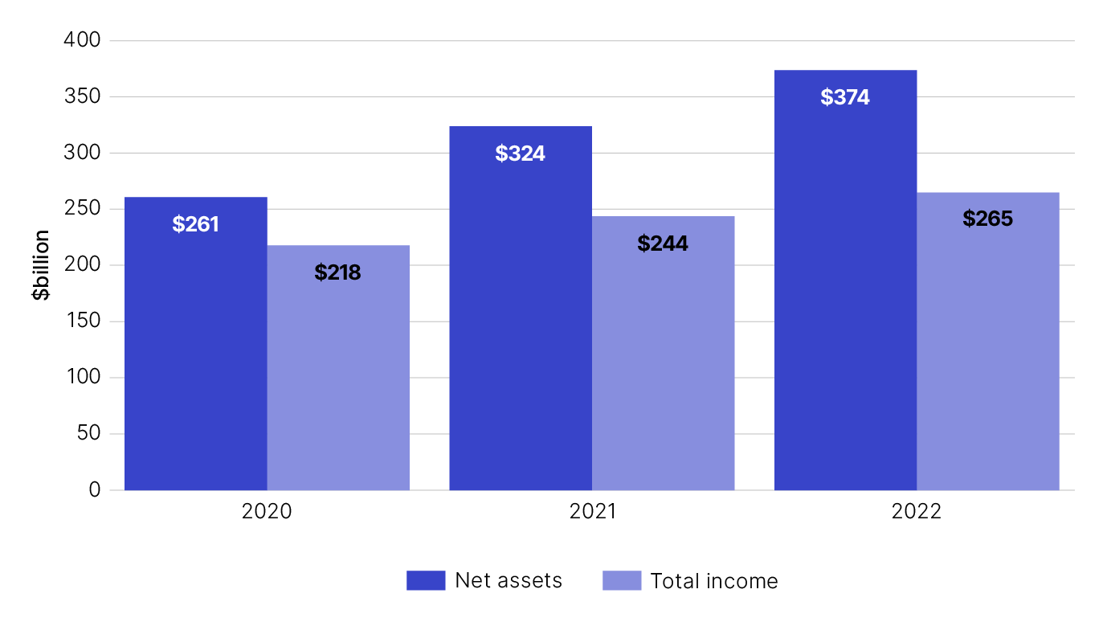

Figure 3: Top 500 income tax and GST paid

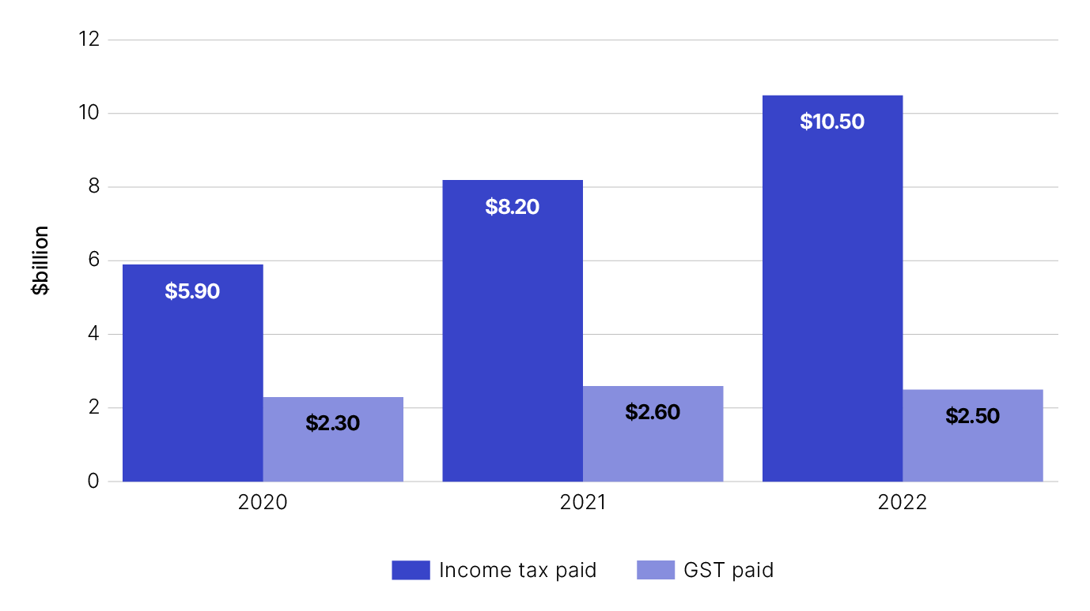

### How much tax we assured

The amount of tax a Top 500 group has paid is verified as correct through our tax assurance process. This involves obtaining evidence and analysing the treatment of material tax issues and providing a high, medium or low rating.

High ratings reflect our assurance of the tax issue, having obtained evidence that the issue is being managed and disclosed correctly. Medium and low ratings reflect the need for more information or investigation of an issue before we can provide a high assurance rating or escalate to a risk review.

For many Top 500s with large and complex groups, achieving high ratings for all tax issues and full tax assurance of entities in a Top 500 group can take several years.

During the 2024 financial year, we assured income tax paid by Top 500 entities totalling $1.646 billion. This result encompasses assurance activities relating to the 2018 to 2022 income years.

Over the life of the Top 500 program, $14.633 billion in income tax has been assured.

### Commercial deals engagements

In the 2024 income year, our teams started 20 Top 500 [commercial deal engagements](https://www.ato.gov.au/businesses-and-organisations/corporate-tax-measures-and-assurance/privately-owned-and-wealthy-groups/what-you-should-know/the-right-services/commercial-deals) with an estimated $17.34 billion in deal value. We also finalised 24 commercial deal engagements (some having commenced in a previous financial year) representing a deal value of $2.52 billion.

In these finalised engagements, we provided tax certainty through agreements with taxpayers on transactions representing net economic activity correctly reported of $810 million. This is based on labels of the tax return that have been assured, including income labels, capital gains amounts and the utilisation of available losses.

Approximately 89% of our finalised commercial deals engagements with Top 500 groups resulted in an agreed position and correct lodgment, reducing the likelihood of audits or disputes in the future. The remainder were dealt with through subsequent review and audit processes.

## Audit results and importance of tax governance

Audit and voluntary disclosure results for Top 500 groups and how effective tax governance can help groups get it right.

In this section

1. Audit, review, and voluntary disclosure results
2. Importance of effective tax governance

### Audit, review, and voluntary disclosure results

During the 2024 financial year, we finalised 22 reviews and 25 audits. As of 30 June 2024, 26 audits and 28 reviews were in progress.

Income tax liabilities of $552.5 million were raised during the 2024 financial year. Of the liabilities raised, $41.3 million were from voluntary disclosures.

During the period 1 July 2019 to 30 June 2024, we raised liabilities totalling $1.55 billion.

Figure 1: Income tax liabilities raised during the 2020–24 financial years

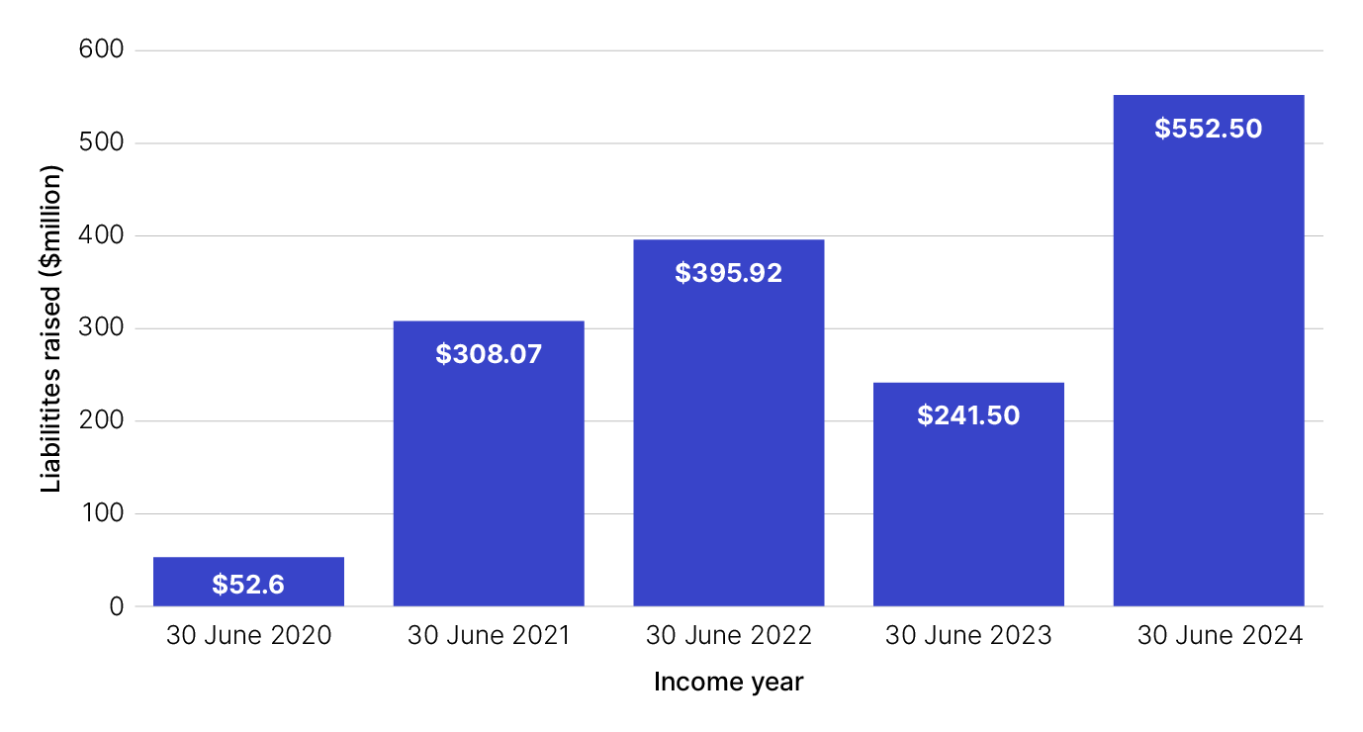

The income tax liabilities raised from the Top 500 population are:

* $52.6 million in 2020
* $308.07 million in 2021
* $395.92 million in 2022
* $241.5 million in 2023
* $552.5 million in 2024.

Audit yield (cash collections arising from our assessments) of $316 million was collected this financial year. For the 2020 to 2024 financial years, we collected $791.4 million. Wider revenue effects (representing future tax impacts of amended assessments) realised this financial year were $14.6 million, totalling $143.3 million since the 2020 financial year.

Total revenue effects for the 2020–24 financial years

|  |  |  |  |  |  |
| --- | --- | --- | --- | --- | --- |
| Revenue type | Financial year ending 2020 | Financial year ending 2021 | Financial year ending 2022 | Financial year ending 2023 | Financial year ending 2024 |
| Audit yield collected ($ millions) | $25.4m | $113.6m | $138.6m | $197.8m | $316m |
| Wider revenue effects ($ millions) | $19.6m | $78.1m | $12.1m | $18.9m | $14.6m |

Figure 2: Total revenue effects for the 2020–24 financial years

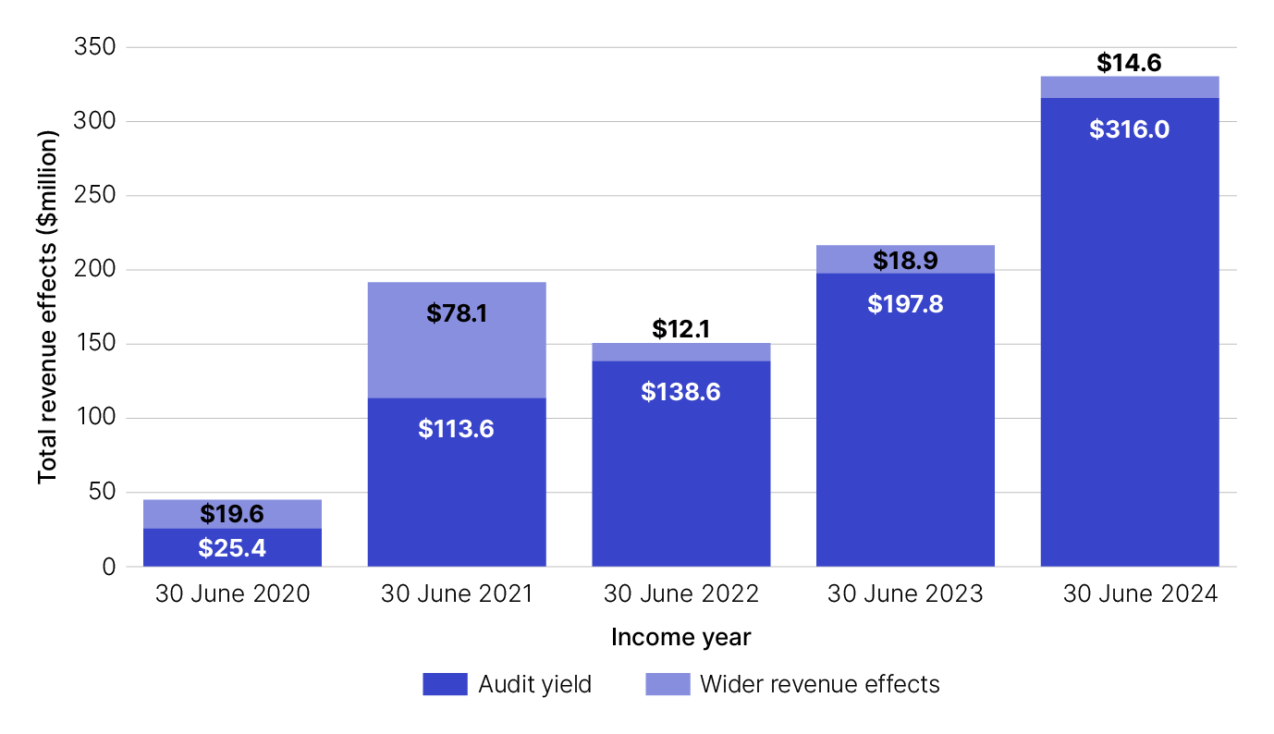

Our audit and review work highlights some of the more complex tax matters affecting Top 500 groups, together with the tax positions adopted. These matters include:

* arrangements that may be designed to obtain a franking benefit (for example, a refund of franking credits), including where the qualified person test has been overlooked or misapplied
* arrangements that may be designed to circumvent the operation of integrity provisions related to unpaid present entitlements and loans made to shareholders and their associates
* related party transactions with self-managed superannuation funds
* international tax matters, including the application of the controlled foreign company provisions, transfer pricing and intangibles migration
* consideration of how the family trust distribution tax provisions are applied
* complex deductibility matters, including related party service or management fee arrangements and where deductions are sought for private pursuits/activities using controlled businesses.

Where groups choose to enter these types of complex arrangements, they sometimes have difficulty substantiating the tax position(s) adopted. This can lead to protracted and costly audit action, together with potentially exposing the group to significant tax liabilities, penalties and interest.

#### Voluntary disclosures

During the 2023–24 financial year, Top 500 groups provided 25 voluntary disclosures that led to an increase of $41.3 million in tax liabilities. 84% of the voluntary disclosures relate to non-complex errors that could easily have been avoided through basic tax governance processes and procedures. These matters included:

* omitted income (for example dividend and trust income)
* overclaiming deductions due to using an incorrect version of the financial records to prepare the tax return
* understated interest income from non-arm’s length (related party) loans
* incorrect calculation of capital losses
* incorrect reporting of capital works and capital allowance deductions.

### Importance of effective tax governance

Top 500 groups control significant amounts of wealth across a range of different industries. In many cases they have large and complex structures consisting of many entities.

Given the economic size of the Top 500 groups, small errors can have a big tax impact. Effective tax governance helps to ensure Top 500 groups get the basics right. 2023–24 data shows 68% of the groups that made errors requiring a voluntary disclosure and 90% of the groups that had additional liabilities raised from audits had minimal or no tax governance.

To avoid costly errors and ensure that the correct amount of tax is being paid, we recommend privately owned and wealthy groups implement tax governance and review it regularly to ensure it's operating effectively.

Tax governance that is documented, operationally effective and regularly reviewed gives us, and the controllers of Top 500 groups, confidence the groups will continue to get things right and mitigate tax risks.

To help Top 500 groups understand and implement the criteria for effective tax governance, we've published [guidance](https://www.ato.gov.au/businesses-and-organisations/corporate-tax-measures-and-assurance/privately-owned-and-wealthy-groups/what-you-should-know/tax-performance-programs-for-private-groups/top-500-private-groups-tax-performance-program/effective-tax-governance-criteria-for-top-500-private-groups) that explains:

* [the importance of effective tax governance and our approach](https://www.ato.gov.au/businesses-and-organisations/corporate-tax-measures-and-assurance/privately-owned-and-wealthy-groups/what-you-should-know/tax-performance-programs-for-private-groups/top-500-private-groups-tax-performance-program/effective-tax-governance-criteria-for-top-500-private-groups/our-approach)
* [required items for effective tax governance](https://www.ato.gov.au/businesses-and-organisations/corporate-tax-measures-and-assurance/privately-owned-and-wealthy-groups/what-you-should-know/tax-performance-programs-for-private-groups/top-500-private-groups-tax-performance-program/effective-tax-governance-criteria-for-top-500-private-groups/required-items)
* [additional items for effective tax governance](https://www.ato.gov.au/businesses-and-organisations/corporate-tax-measures-and-assurance/privately-owned-and-wealthy-groups/what-you-should-know/tax-performance-programs-for-private-groups/top-500-private-groups-tax-performance-program/effective-tax-governance-criteria-for-top-500-private-groups/additional-items)
* [further guidance and practical examples](https://www.ato.gov.au/businesses-and-organisations/corporate-tax-measures-and-assurance/privately-owned-and-wealthy-groups/what-you-should-know/tax-performance-programs-for-private-groups/top-500-private-groups-tax-performance-program/effective-tax-governance-criteria-for-top-500-private-groups/further-guidance)

## Justified trust framework

Learn about justified trust and how the Top 500 groups performed against the 4 key areas.

In this section

1. Achieving justified trust and benefits for Top 500 groups
2. Differentiated approaches to assurance and justified trust

### Achieving justified trust and benefits for Top 500 groups

To achieve justified trust, we seek objective evidence that would lead a reasonable person to conclude that the Top 500 group paid the right amount of tax and will continue to pay the right amount of tax. This is a higher level of confidence than confirming that certain risks do not arise. We tailor our approach based on the unique business profile of a Top 500 group.

For justified trust, the Top 500 group must satisfy the following 4 key areas.

* The group has effective tax governance in place to support current and future compliance.
* Risks flagged to market in our Public Ruling and Taxpayer Alerts programs are not present in the group or are appropriately mitigated.
* Tax outcomes from both ongoing and atypical transactions are understood and agreed as correct.
* Differences in accounting and tax results are complete and can be explained in context.

Achieving justified trust is valuable for the group, and the tax system, as the group enters the 3-year monitoring and maintenance phase.

#### Monitoring and maintenance phase

When a Top 500 group attains an overall high assurance rating under our justified trust assurance program, we have confidence that they have complied, and will continue to comply, with income tax laws and the group is placed into justified trust.

In recognition of the high levels of trust we have in the tax outcomes reported by Top 500 groups in justified trust, we scale down our engagement interactions for the following 3 financial years. During this time, we largely rely on the effectiveness of the group’s tax governance framework to ensure correct reporting in tax returns, and that the correct amount of tax is paid.

We continue to engage with the private group during this [monitoring and maintenance](https://www.ato.gov.au/businesses-and-organisations/corporate-tax-measures-and-assurance/privately-owned-and-wealthy-groups/what-you-should-know/tax-performance-programs-for-private-groups/top-500-private-groups-tax-performance-program) period through annual check-ins that are limited in scope.

### Differentiated approaches to assurance and justified trust

Differentiated approaches were developed to streamline the tax assurance process and tax governance requirements for groups that have limited complexity in the tax issues that require assurance, including:

* passive investors
* High-volume trading businesses with minimal value add
* Top 500 groups with audited financial statements

#### Passive investors

Top 500 groups that predominantly generate income of a passive nature, generally treat the tax issues they have correctly. Our [passive investor guide](https://www.ato.gov.au/businesses-and-organisations/corporate-tax-measures-and-assurance/privately-owned-and-wealthy-groups/what-you-should-know/tax-performance-programs-for-private-groups/top-500-private-groups-tax-performance-program/effective-tax-governance-criteria-for-top-500-private-groups/passive-investor-guide-for-top-500-private-groups) outlines the provisional justified trust approach which operates as a gateway to full justified trust. It gives fully assured passive investor groups a break from assurance activities to focus on developing their tax governance, without the requirement for operational effectiveness testing.

In the 2023–24 financial year, 2 passive investor Top 500 groups entered into provisional justified trust, with more expected to join provisional justified trust in 2024–25.

#### High-volume trading businesses with minimal value add

We have identified 61 Top 500 groups that buy and sell trading stock without adding value to the goods being sold, for example grocery and vehicle retailers. These businesses are highly systemised and generally have fewer tax issues of potential concern.

Accordingly, we have taken a differentiated approach to engaging with this group that involves streamlining assurance and tax governance requirements.

#### Top 500 groups with financial statements audited by an external auditor

For legal, personal and commercial reasons, many Top 500 groups have the financial statements of group entities audited by qualified external auditors.

We've simplified our assurance approach for entities within Top 500 groups that use audited financial statements to recognise these efficiencies and avoid duplication.

Figure 1: Top 500 groups' progress towards justified trust as at 30 June 2024

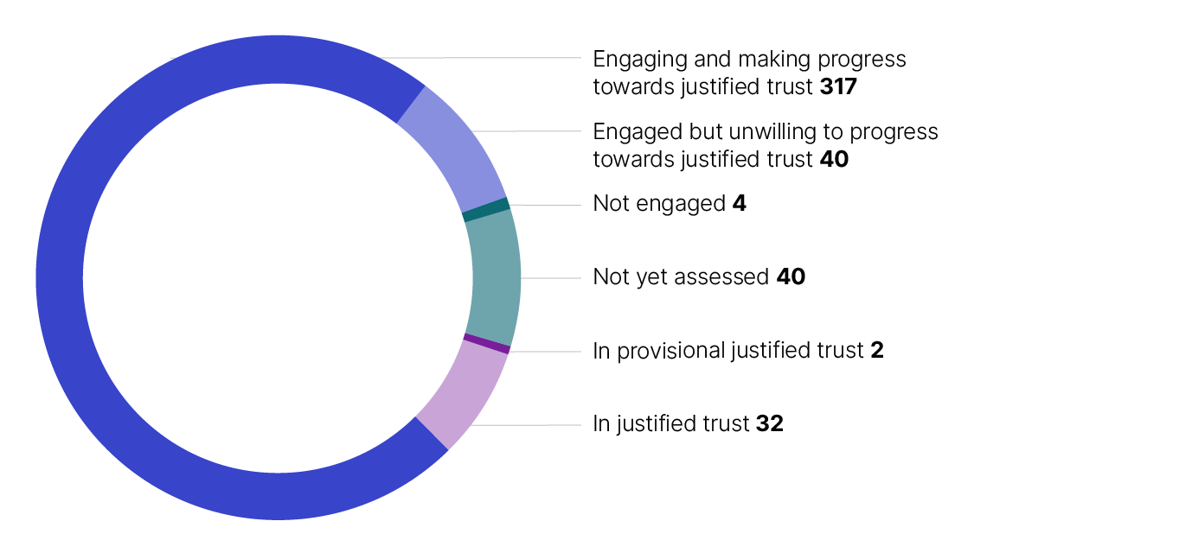

At the end of the 2024 financial year:

* 317 are engaging and making progress towards justified trust
* 40 are engaged but unwilling to progress towards justified trust
* 40 are not yet assessed
* 32 are in justified trust
* 4 are not engaged
* 2 are in provisional justified trust.

## Tax governance and key issues for Top 500 groups

Tax governance principles explained, key findings, observations and tax issues that attracted our attention.

In this section

1. Tax governance
2. Tax issues for Top 500 groups

### Tax governance

The first key area of justified trust focuses on ensuring effective tax governance is in place to support current and future compliance. Our engagement teams encourage Top 500 groups to show us their documented tax governance frameworks, processes and procedures. We assess the effectiveness of those controls with the assistance of our internal tax governance tool.

This tool provides a consistent method for our teams to assess the tax governance in place for the group's active trading entities and non-trading (passive investment) entities. It also helps to evaluate the effectiveness of tax governance processes in place for wealth extraction from those entities (for example, via trust distributions, payments and dividends).

Each group’s tax governance framework is assessed against 7 principles of effective tax governance for privately owned groups, with an emphasis on the first 4 principles:

* accountable management and oversight
* recognise tax risks
* seek advice
* integrity in reporting.

Note: In GST assurance engagements, only the 2 principles of ‘recognise tax risks’ and ‘integrity in reporting’ are considered for assessing GST governance.

The 3 remaining principles are not considered on a stand-alone basis, rather their qualitative aspects remain important to how we view each Top 500 group’s engagement with the tax system.

These are:

* professional and productive relationships
* timely lodgments and payments
* ethical and responsible behaviours.

Our assessment and [rating](https://www.ato.gov.au/businesses-and-organisations/corporate-tax-measures-and-assurance/privately-owned-and-wealthy-groups/what-you-should-know/tax-performance-programs-for-private-groups/top-500-private-groups-tax-performance-program/how-we-assess-tax-governance-for-top-500-privately-owned-groups) of the group’s tax governance is based on the evidence provided to demonstrate the 3 core elements of existence, design effectiveness and operational effectiveness.

Our key findings and observations on the effectiveness of tax governance across Top 500 groups is outlined below.

114 Top 500 groups had tax governance over their trading activities which were rated:

* 46% highly effective
* 34% medium effectiveness
* 20% low effectiveness.

Figure 1: Tax governance ratings for trading entities across 114 groups

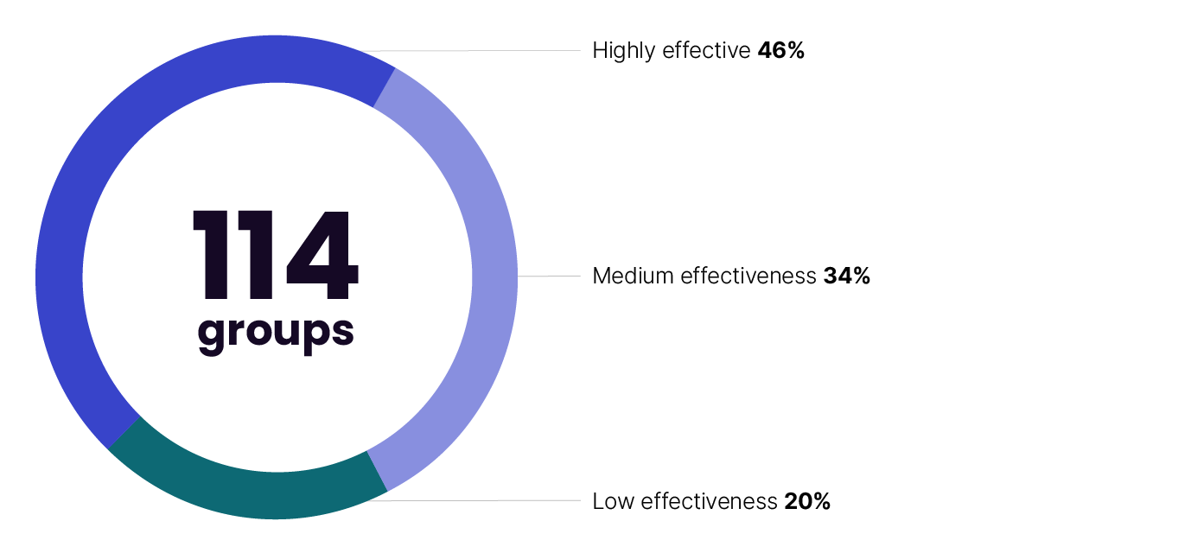

111 Top 500 groups had tax governance over their non-trading activities which were rated:

* 45% highly effective
* 31% medium effectiveness
* 24% low effectiveness.

Figure 2: Tax governance ratings for non-trading entities across 111 groups

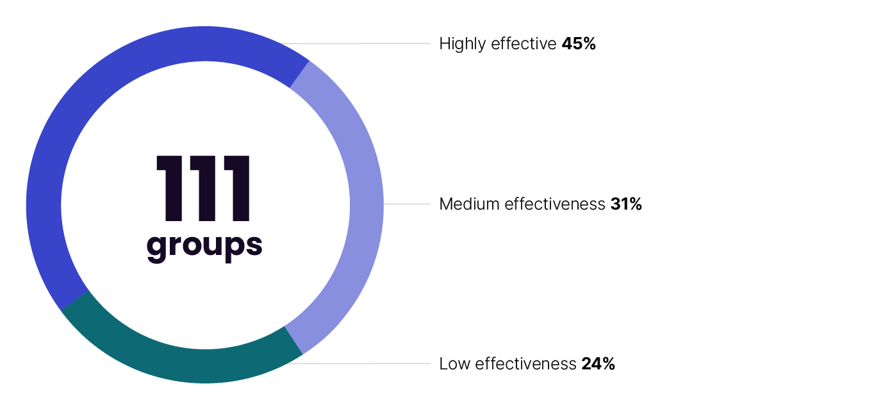

104 Top 500 groups had tax governance over their wealth extraction activities which were rated:

* 50% highly effective
* 28% medium effectiveness
* 22% low effectiveness.

Figure 3: Tax governance ratings for wealth extraction across 104 groups

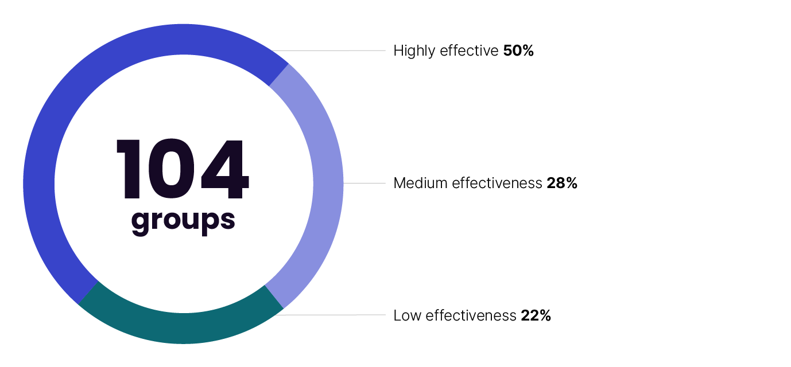

#### Observations

Over one third of Top 500 groups have implemented some level of documented tax governance. This proportion is increasing with a 20% increase in the number of groups with tax governance across trading, non-trading and wealth extraction activities compared to last year. Our data also shows most groups that have recently implemented tax governance, or that have not previously had their tax governance assessed, are achieving medium or high ratings. This is a positive reflection of our published tax governance guidance.

While most Top 500 groups have some tax governance in place, the majority don't document it. This raises doubts about its effectiveness, particularly if there is reliance on a key person and there are no safeguards to mitigate the key person risk. While the majority of those groups have not had instances of poor tax compliance, our findings show past performance is no guarantee of future results.

The cost of implementation and questions on necessity are often reasons for not having documented tax governance. We encourage groups to consider the scale and needs of their group. Groups with simple affairs do not need elaborate tax governance procedures, and, in most cases, simply documenting their internal processes is sufficient and the most cost-effective approach.

For groups with documented tax governance, the primary area for improvement relates to the second principle of recognising and managing tax issues and risks. Many groups tell us their tax agents are responsible for this aspect, but we find the group is responsible for providing figures for the tax return, and there are minimal or no checks done by the tax agent to ensure their integrity. In those instances, groups should have an internal process or procedure for ensuring the integrity of the financial data provided to the tax agent. Our expectation is that Top 500 groups have a documented end-to-end process in place for recognising and managing tax issues. This includes:

* a register of material and tax sensitive issues and procedures for ensuring the correct tax treatment of significant transactions
* instructions for preparing tax reconciliations and disclosures (or extracting and checking the data provided to tax agents)
* the process of checking and signing-off the tax return.

Other areas for improvement include the following.

* Where a tax agent is used, have a detailed engagement letter and scope of works to ensure clear lines of responsibility.
* Have a lodgment and payment calendar to ensure obligations are met on time. Our published guidance includes an [example of a lodgment and payment calendar](https://www.ato.gov.au/businesses-and-organisations/corporate-tax-measures-and-assurance/privately-owned-and-wealthy-groups/what-you-should-know/tax-performance-programs-for-private-groups/top-500-private-groups-tax-performance-program/effective-tax-governance-criteria-for-top-500-private-groups/further-guidance) that can be adapted by Top 500 groups.
* Have effective controls for data and information used internally to prepare the return and provide to external tax agents. For example, procedures for checking that accounting profit in the return matches closed and finalised accounts.
* Procedures that specify when advice should be sought, including clear quantitative and qualitative thresholds when advice will be sought, who is responsible for seeking that advice and the process for engaging external advisors and the ATO.

There have also been weaknesses observed in GST governance frameworks for some Top 500 groups. Our recommendations for improving GST governance includes:

* documenting BAS procedures
* regular processes to verify GST registration of suppliers subsequent to initial setup
* periodic internal control testing and regular data testing processes
* reconciliation of data between the BAS, income tax return and financial statements.

### Tax issues for Top 500 groups

There are 3 remaining key areas of justified trust:

* tax risks flagged to the market
* treatment of tax issues from ongoing and atypical transactions
* alignment of tax and accounting outcomes.

These areas are addressed by the Top 500 program through assuring material tax issues for each Top 500 group.

For certain tax issues, such as income from business-as-usual activities, most groups are achieving high assurance. However, other tax issues, particularly those related to wealth extraction, tend to get lower levels of assurance and in some cases result in amended assessments. The following sections outline specific tax issues that attracted our attention during the year ended 30 June 2024.

#### Business as usual income and deductions

Most transactions where we seek to understand the tax treatment in Top 500 engagements are related to ongoing (or ‘business as usual’) activities. Our focus on the basics reflects the purpose of the Top 500 program, to assure that Australia’s largest private groups are paying the correct amount of tax. Accordingly, we need to understand the routine, regular, and ongoing transactions that Top 500 groups engage in, and the tax treatments applied.

In engagements where we have finalised our analysis, most groups achieved high assurance for business-as-usual income and deductions issues, with only 5% having a low assurance rating requiring further investigation.

#### Private company loans and benefits

Compliance with [Division 7A](https://www.ato.gov.au/businesses-and-organisations/corporate-tax-measures-and-assurance/private-company-benefits-division-7a-dividends) continues to feature in many Top 500 engagements to ensure that benefits obtained from private companies by the controllers of private groups, and their associates, are correctly reported for tax purposes. In engagements where we finalised our analysis in respect of Division 7A issues, more than 25 per cent raised red flags that required escalation to a review or audit.

Our analysis of a group’s compliance with Division 7A includes:

* confirming that payments to shareholders or their associates have been recorded and disclosed
* verifying that the minimum yearly repayments on loans are correct
* considering transactions involving debt forgiveness
* examining whether company property has been used for personal purposes
* analysing whether unpaid present entitlements have been brought to account.

Although there are instances where we have granted the Commissioner’s discretion to not treat some arrangements as deemed dividends, our view is that the largest private groups have access to the expertise to help them prevent honest mistakes or inadvertent errors.

#### Trusts issues

Many Top 500 groups have entities that have made Family Trust Elections (FTEs) or Interposed Entity Elections (IEEs). During the 2023–24 financial year, we observed that some private groups have multiple specified individuals in elections made by group entities. This will typically mean that there are multiple family groups for the purposes of the Family Trust Distribution Tax (FTDT) provisions, which may result in FTDT exposure.

We encourage private groups to have effective tax governance to ensure that distributions are kept within the relevant family group, including the following annual checks:

* reviewing all elections in place, including checking records held by current or previous advisors
* whether the specified individual remains the most suitable person and if not, whether the specified individual can and should be [varied](https://www.ato.gov.au/businesses-and-organisations/trusts/in-detail/family-trusts-concessions)
* the timeframes to vary or revoke elections – noting these are limited and that outside these periods, the elections and the specified individuals can’t be changed.

We continue to have audit cases on hand where we are considering the application of the integrity rules in section 100A of the Income Tax Assessment Act 1936. These rules may apply when a trustee makes trust distributions to beneficiaries on low marginal tax rates whilst the economic benefits of the trust income is provided to individuals who would otherwise pay the top marginal rate of tax.

#### Private ancillary funds

Many Top 500 groups have a link to not-for-profit (NFP) entities, with a high proportion taking the form of private ancillary funds (PAF), to facilitate philanthropic pursuits.

The prevalence of NFPs in the Top 500 population is encouraging, however it is important for those groups to be mindful of the integrity rules that apply to NFPs due to their concessional tax status. For example, arrangements that can contravene the integrity rules include where a private group establishes a PAF and the founder gifts funds to the PAF (for which they claim a tax deduction), and the PAF then reinvests these funds back into the private group. This allows the founder to retain access to and use of the gifted funds. These arrangements can result in funds being diverted from a PAF pursuing its charitable purpose.

In these circumstances, the PAF may lose its concessional tax status and the trustee of the PAF and its directors may incur penalties. In some circumstances, the founder may also be denied a tax deduction as the gift to the PAF fails the gift criteria.

Top 500 groups with NFPs should ensure they are aware of and comply with the obligations and responsibilities attached to NFPs.

#### Capital gains tax

Top 500 groups regularly engage in transactions that result in the application of the [capital gains tax](https://www.ato.gov.au/individuals-and-families/investments-and-assets/capital-gains-tax) (CGT) provisions. These transactions involve the disposal of assets, for example real property, shares in a company, units in a trust and rights.

In assuring the tax treatment of an asset disposal, we often review:

* the accuracy of CGT calculations, including the application of capital losses and the availability of CGT concessions, rollovers and discounts
* the pre-CGT status of assets
* whether the disposal of an asset should be reported on capital or revenue account.

Based on the assurance engagements finalised during the 2024 financial year, most Top 500 groups correctly applied the CGT provisions to the atypical transactions they undertook. A high level of assurance was attained for approximately 94% of the transactions we examined. Many Top 500 groups also have significant asset disposals examined under our [commercial deals program](https://www.ato.gov.au/businesses-and-organisations/corporate-tax-measures-and-assurance/privately-owned-and-wealthy-groups/what-you-should-know/the-right-services/commercial-deals) to provide tax certainty pre-lodgment or in some cases shortly after lodgment.

## Top 500 client survey

The feedback received and lessons learned from our annual Top 500 client survey.

The Top 500 client engagement survey is conducted annually to better understand the experience of Top 500 groups and advisors, from their involvement with the program.

In April 2024, surveys were issued to either an in-house representative or nominated advisor, for each private group. For the first time this year, advisors had the opportunity to complete one survey on behalf of multiple clients.

The response rate to this year’s survey was 39%, an increase of 18 points from 2023, with 43% of groups being represented in survey responses.

The survey results illustrate that 66% of respondents are satisfied with the program, an increase of 8% from 2023. To view the feedback and responses to this year’s survey, see [Top 500 client survey summary – April 2024](~/link.aspx?_id=78A4C769E4E247FF9FDF57AA3225CB52&_z=z).

Key insights from this year’s survey are included below.

* We are consistently rated highly for our professionalism and transparency, with Top 500 groups valuing the tailored one-to-one relationship and direct point of access to the ATO that the Top 500 program affords.
* There is a growing level of satisfaction with the level of communication between private groups and our engagement teams. Respondents would like us to be mindful about the amount and timing of information requests and would like more regular updates and feedback on information they’ve provided.
* While many respondents still see the program as costly, this year more respondents could see how our engagements reduced the cost of meeting tax obligations. The majority also agree that engaging with the ATO as part of the Top 500 program helps to avoid disputes later on.
* We continue to see shifts in attitudes toward tax governance, with more groups implementing tax governance and recognising the benefits within their businesses each year.
* While most respondents (77%) can see how tax governance assists with meeting tax obligations, only 56% feel encouraged to make the investment in improving tax governance.
* Some clients are dissatisfied with the length and ongoing nature of the engagements, and the focus on historical years.

The most significant area of dissatisfaction with the program for Top 500 groups is cost. We acknowledge costs can be significant, particularly for the many groups that use external advisors. We consider that Top 500 groups can reduce the costs associated with annual assurance engagements by working towards full tax assurance and justified trust. To this end, we will continue to:

* work with Top 500 groups to bring engagements closer to real-time and develop clear plans to achieve full tax assurance
* provide additional guidance on tax governance, and educate groups about the benefits, including through articles in the ATO newsrooms and newsletters such as the Business Bulletin and Tax Professionals News
* expand our provisional justified trust for groups that tend to get things right.

For the groups that choose not to pursue justified trust, the costs they incur will be necessary to give the community and government confidence that Australia’s wealthiest groups are paying the correct amount of tax.

### Keep up to date

We have tailored communication channels for medium, large and multinational businesses, to keep you up to date with updates and changes you need to know.

Read more articles in our online [Business bulletins newsroom](https://www.ato.gov.au/businesses-and-organisations/business-bulletins-newsroom).

Subscribe to our:

* [Business bulletins email newsletter](https://subscribe.news.ato.gov.au/link/id/zzzz5cbe7b4e8b790364/page.html?prompt=1&) – issued fortnightly
* [email notifications](https://www.ato.gov.au/ato-forms/Subscribe-to-email-updates) about new and updated information on our website – you can choose to receive updates relevant to your situation. Choose the 'Business and organisations' category to ensure your subscription includes notifications for more Business bulletins newsroom articles like this one.